Per usual, I’ve decided to bake part of my homework. I’m going to return here to flesh out the actual critical component and my actual map project using Google Earth, but I wanted to provide the Critical Baking rationale. My Google Earth link is here. As you can see, my actual map this week seeks to accomplish two things: first, to track representation of marginalized groups and diversity in the Pokemon game franchise, and second, to serve as a sort of ‘first draft’ of a history timeline project that I’m going to be working on in Twine for the T&T in History class that covers roughly the same content (albeit in a much different format). I’ve just barely started scratching the surface with this as of this posting (Monday night at 8:45 P.M.), but I want to spend much more time with it this week because it has to do with content that I believe will become my dissertation. I'm interested in tracking the sorts of increase in representation and representation issues through the continued development of the Pokemon regions. For example, we began with the Kanto region with the first releases, which maps nicely onto a real world location which happens to be an area of Japan called the Kanto region. Johto, our second region, quite literally touches up to Kanto (both in game and in reality, again, although in reality this region is called 'Kansai') but we already start to have some different affordances for identity and difference, here. For example, in the Johto games, we are first able to select a gender for our character -- the player is, by default, a boy in the first generation games. The acknowledgement of gender in Generation II has virtually no impact on game play apart from minor sprite variations (and I do mean minor when we think of the graphic capabilities of the Game Boy Advance). Gen II also introduces to us, in the Japanese iterations of the games, characters who 'speak' in a Kansai accent -- this linguistic variance is more or less absent in the English version of the games, to my recollection.
In any case, I have a lot to work with, here, and will continue to do so. The below progress image shows my first regional bubbles for the first four regions we see in Pokemon across the first four generations (Sinnoh/Hisui returning in Legends of Arceus), which I'm hoping to fill in much more this week...
I also baked a pound cake and some zucchini bread, which, per usual, will be in the T&T Office for sharing tomorrow morning. Remnants will be taken to T&T in History.
So, why this pound cake, and that zucchini bread…for maps week? There certainly don’t appear to be any maps on these baked goods. I suppose I was interested in tracing my baking lineage, or rather, my lineage, bakerly. The pound cake is my paternal great great grandmother’s recipe, and the zucchini bread is my maternal great grandmother’s recipe. These are both recipes I’ve been making since I was quite young, but never at the same time, never together. I picked one recipe from the families of each of my parents to share. Coincidentally, I happened to have a bunch of my recipes out to transcribe into a pretty notebook this week because many of my family recipes look like... well, this. That's my maternal great grandmother's handwriting. She's been dead since 1994. I believe that this copy of the pound cake recipe was written on a typewriter by my father in the 1980s. These are actually two of the recipe cards/papers that are in better condition. Some of them I can barely make out and if I didn't have them memorized, I wouldn't be able to read them anymore. I'm honestly not even sure if some of my maternal great grandmother's are in English. She was Slovak. Very few of the recipes from this side of my family are written down at all -- most of them were passed orally. My mother actually explicitly forbade me from ever writing down the pierogi recipe when I was quite young. The first time I tried to make them on my own I got very frustrated because there aren't any measurements for that one -- everything is by feel, by look, by texture, by sound (yes, you can 'hear' when the dough is ready). I guess I could make those for critical baking sometime, but pierogis are hardly baked goods and frankly, a batch of them takes about 8 hours between the dough rolling, ingredient cooking, actual pierogi stuffing and folding, boiling, and then frying. They are quite delicious, however.
Interestingly enough, this exercise made me realize something related to my bakerly lineage. I have very few 'from scratch' baking recipes from my maternal family, however, I do have dozens and dozens of savory cooking dishes from scratch, things like those pierogis, stuffed cabbages, stuffed peppers, haluski (cabbage and noodles), assorted cabbage recipes, soups -- you know, actual food that people eat as part of their daily lives (at least people from my ethnic background, I suppose), just none of them are written down. I actually made a pot of stuffed cabbages for my lunches this week. I am not particularly close with my father's family; my parents separated and divorced when I was an infant, and I saw him quite seldom. The pound cake is the one recipe I do have from his family, and it's something I specifically taught myself how to make from this recipe card with a bit of help from my mom long after their divorce. I'm told by family members who remember my father's iteration that while mine is very good, it's just ever so slightly different from his -- I've always wondered what little secret tip or trick he must've done that isn't in the recipe card. I'm sure there's something, because the few recipe cards I do have from my maternal side are missing all sorts of little details that I only realized weren't actually written in the recipe when I went to copy them down into my notebook. 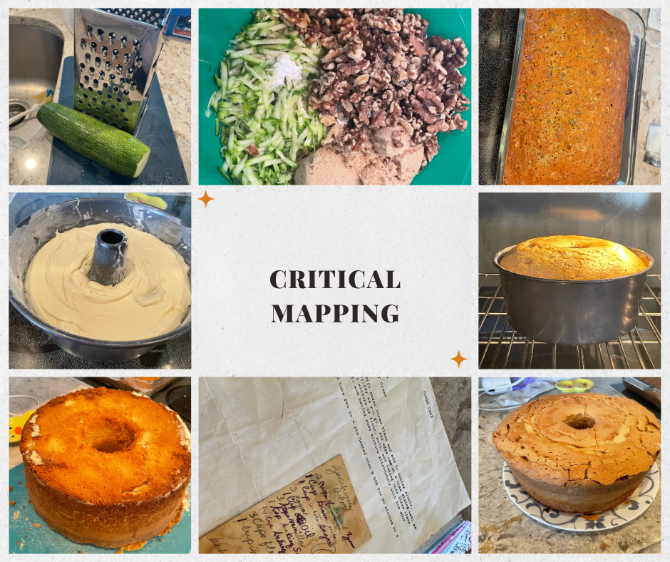
I suppose if I were to attempt to tie my bakerly lineage into my Pokemon map, it would be halfway doable. The women these recipes came from were from Scotland and Slovakia. I suppose my maternal great grandmother did spend part of her life in the United States, however, she most definitely did not live in either of the two places that are current U.S. territories/states that are mapped on in Pokemon regions (which are Hawaii and New York City). My Scottish heritage can be mapped directly onto Pokemon's Galar Region, which broadly represents Great Britain, and the Crown Tundra expansion pass more directly nodding to Scotland itself.

